PowerShell Interacting with SQL Server
Lab Execution and GitHub Publishing — Step-by-Step Guide

Part 1: Running the Lab
Walk through each step in order, running the corresponding script section and capturing the listed screenshot before moving on. Run everything from the project root folder so relative paths like .\data\students.xml resolve correctly.

Step 01 — Create the Project Folder
Create a dedicated folder for this lab. This keeps scripts, screenshots, and docs organized.
mkdir PowerShell-Interacting-with-SQL-Server
cd PowerShell-Interacting-with-SQL-Server
mkdir scripts, screenshots, docs
Open the folder in File Explorer or VS Code (code .) and confirm you see scripts, screenshots, and docs subfolders.
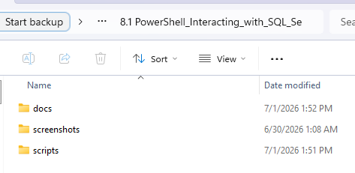
File Explorer showing this folder structure.

Step 02 — Connect to the Database
Create scripts\Task1-Connect-Database.ps1 (reuse the connector load + connection string from the Accessing SQL Server lab) and confirm it connects before moving on.
[void][System.Reflection.Assembly]::LoadFrom("C:\Program Files (x86)\MySQL\MySQL Connector NET 8.1.0\MySql.Data.dll")
$connection = New-Object MySql.Data.MySqlClient.MySqlConnection
$connection.ConnectionString = "server=ServerName; port=3306; user=YourUsername; password=YourPassword; database=powershell_lab; pooling=false"
$connection.Open()
if ($connection.State -eq [System.Data.ConnectionState]::Open) {
Write-Host "Connected to SQL Server."
} else {
Write-Host "Failed to connect to SQL Server."
}
Replace ServerName, YourUsername, and YourPassword with your actual database server details. Expected console output: Connected to SQL Server.
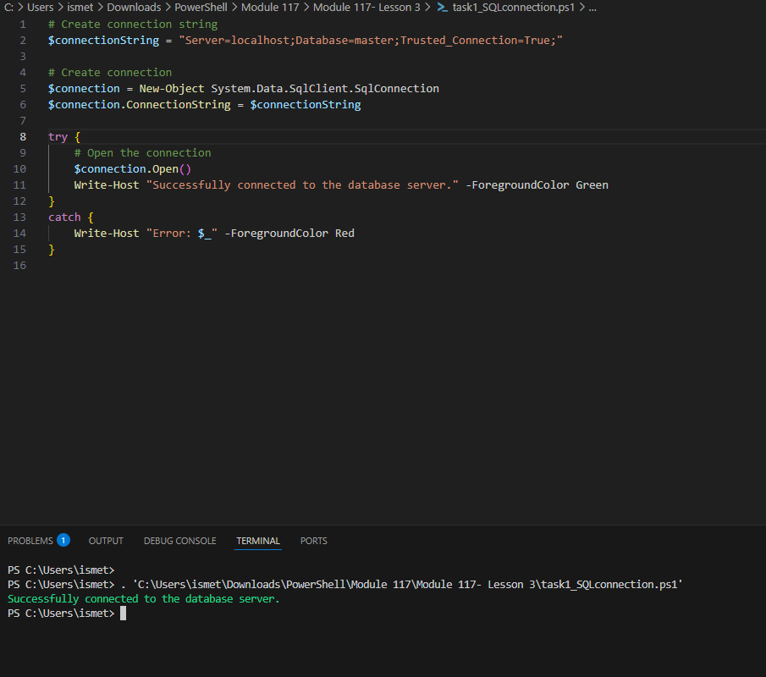Terminal showing the successful connection message.

Step 03 — Insert New Data
Create scripts\Task2-Insert-Data.ps1. Insert a new product record into the Products table.
$insertQuery = "INSERT INTO Products (ProductName, Price) VALUES ('Wireless Mouse', 19.99)"
$insertCommand = $connection.CreateCommand()
$insertCommand.CommandText = $insertQuery
$insertCommand.ExecuteNonQuery()
No error after running. ExecuteNonQuery() returns the number of affected rows (should be 1).
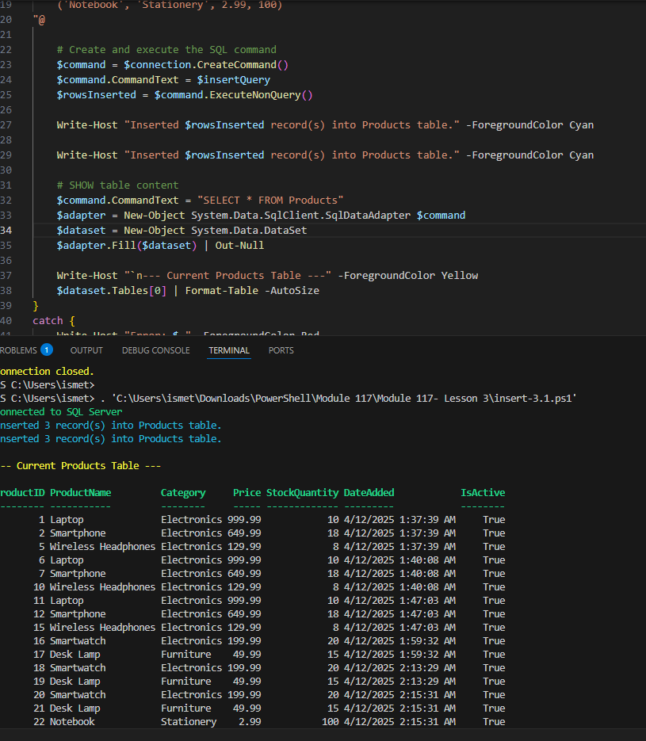
Terminal showing the insert command executed without errors.

Step 04 — Confirm the Insert
Run a SELECT query against the Products table to confirm the new row was added.
$query = "SELECT * FROM Products WHERE ProductName = 'Wireless Mouse'"
$command = $connection.CreateCommand()
$command.CommandText = $query
$reader = $command.ExecuteReader()
while ($reader.Read()) {
Write-Host "Product: $($reader["ProductName"]), Price: $($reader["Price"])"
}
$reader.Close()
Expected console output: Product: Wireless Mouse, Price: 129.99
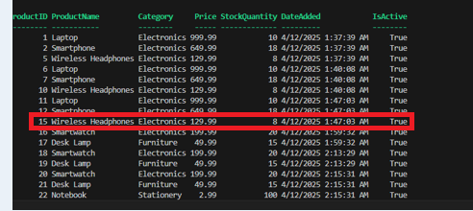
Terminal output showing the newly inserted product.

Step 05 — Update Existing Data
Create scripts\Task3-Update-Data.ps1. Update the price of the Wireless Mouse product.
$updateQuery = "UPDATE Products SET Price = 24.99 WHERE ProductName = 'Wireless Mouse'"
$updateCommand = $connection.CreateCommand()
$updateCommand.CommandText = $updateQuery
$updateCommand.ExecuteNonQuery()
No error after running. ExecuteNonQuery() should return 1 (one row affected).
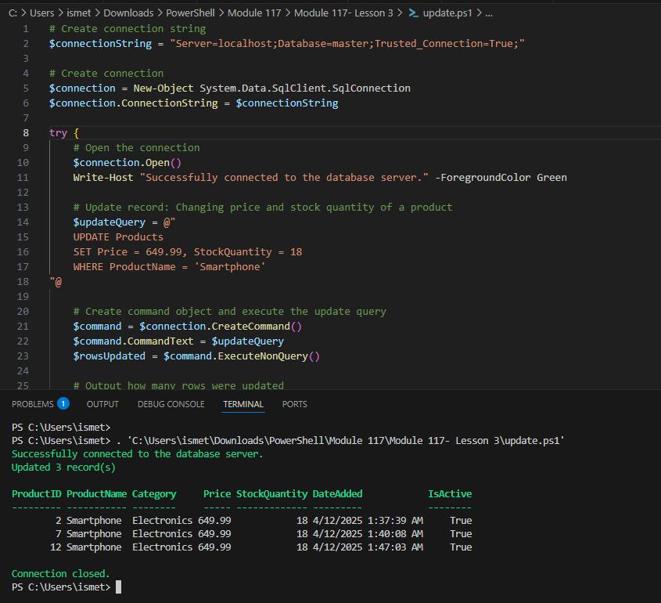
Terminal showing the update command executed without errors.

Step 06 — Confirm the Update
Re-run the SELECT query from Step 04 to confirm the price changed.
Product: Wireless Mouse, Price: 24.99
Expected console output showing the updated price.

Step 07 — Delete Data
Create scripts\Task4-Delete-Data.ps1. Delete the Wireless Mouse product from the Products table.
$deleteQuery = "DELETE FROM Products WHERE ProductName = 'Wireless Mouse'"
$deleteCommand = $connection.CreateCommand()
$deleteCommand.CommandText = $deleteQuery
$deleteCommand.ExecuteNonQuery()
No error after running. ExecuteNonQuery() should return 1 (one row affected).
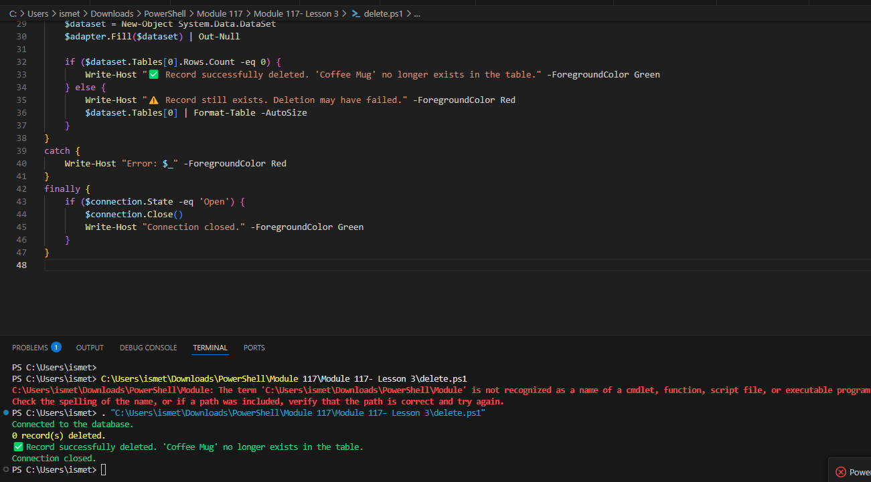
Terminal showing the delete command executed without errors.

Step 08 — Confirm the Deletion
Re-run the SELECT query from Step 04 to confirm the row no longer exists.
$reader = $command.ExecuteReader()
if (-not $reader.HasRows) {
Write-Host "No matching product found — deletion confirmed."
}
$reader.Close()
Expected console output: No matching product found — deletion confirmed.

Step 09 — Close the Connection
Add $connection.Close() at the end and run all four task scripts end-to-end in sequence (connect → insert → update → delete) to confirm the full flow works cleanly.
$connection.Close()

Step 10 — Verify Final Files
Open File Explorer at the project root and confirm scripts/ has Task1-Connect-Database.ps1, Task2-Insert-Data.ps1, Task3-Update-Data.ps1, and Task4-Delete-Data.ps1, and screenshots/ has all your captures.ly on the repo home page.

